1. My organization wants to send some additional offers to those customers who have booked a Luxury car. For this purpose, they want all these customers first name, last name and phone number. Write a query displaying this.

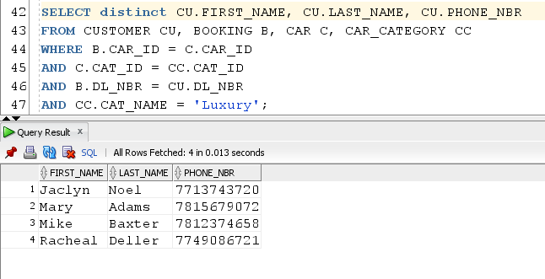

1. Get the total number of bookings for each location. Also display the location details.

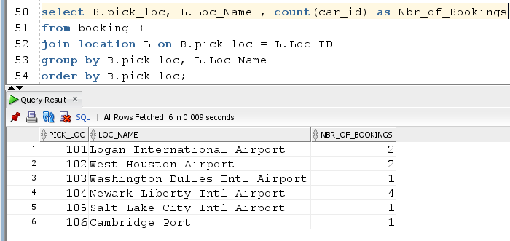

1. Write a query to display booking details of those cars whose price was changed and the booking was made after this price change.

History table: Price changed on 23-Nov-2020 and 2 bookings were made on 24-Nov-2020 for these cars. So, our query should display records with booking id ‘B012’ & ‘B1013’.

It should not display records for booking ‘B1014’

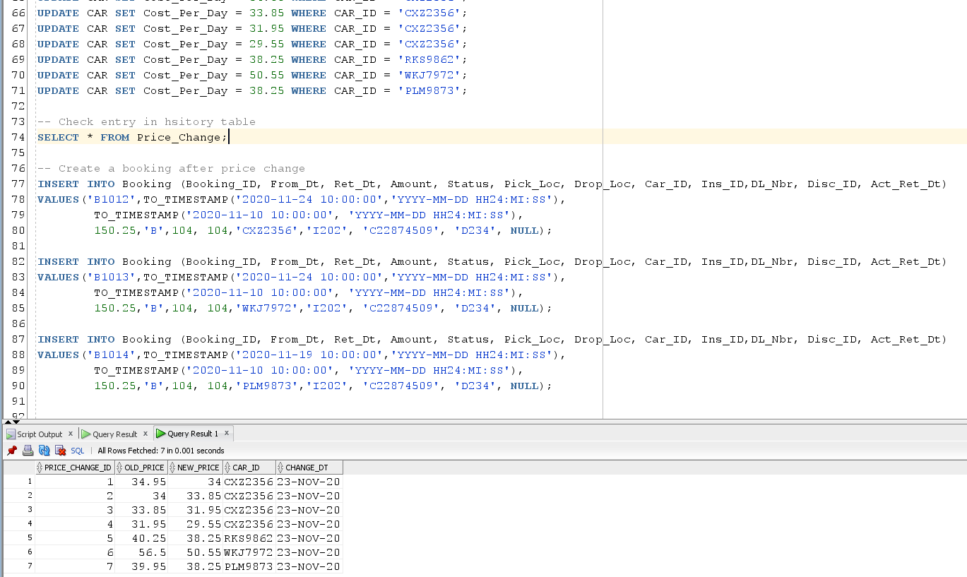

Output query result:

